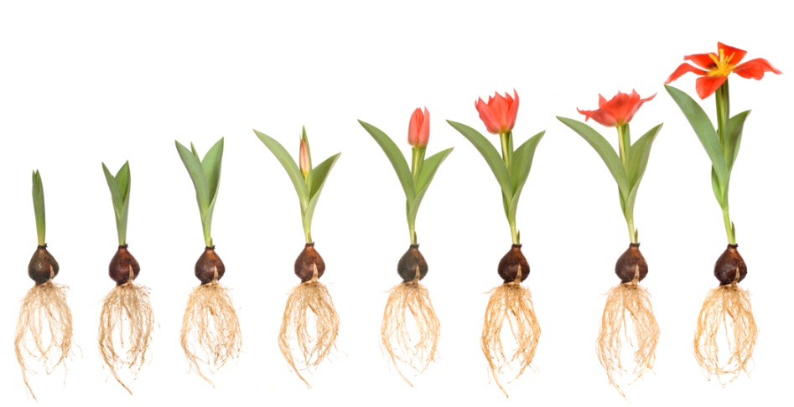Name:___________________

**Year 7 Biology Vocab Revision Chapter 5.1**

*Write down the correct term for each of the following definitions:*

1. Depending on each other for survival
2. The place where all live exists
3. An organism that benefits from living on or within another and the other is harmed-
4. Active at night
5. Living factors in an organisms environment
6. Scientists who study the interactions between living things and their environment
7. A relationship where both organisms benefit
8. A relationship where one benefits and the other is harmed
9. A characteristic that helps an organism survive and reproduce in their environment
10. The place where an organism lives
11. Non-living factors in an organisms environment
12. A relationship where one organisms benefits and the other is neither benefitted nor harmed
13. An organism on or in which a parasite lives
14. A plant that lives on another plant, not as a parasite but for support
15. The study of living things